How to fight misinformation with facts

Tony Noerpel

In a series of articles, I am exploring how we can rebuild economic theory so that it is constructive rather than destructive and how good economic theory can be applied to designing the Green New Deal, which we desperately need if we are to survive as a species.

It is obvious that any one of us doesn't know everything, so we have to rely on a network of other people, i.e., cooperation, socialism, and community to help us form an understanding of the world and make progress. I would submit that it is not our tiny brains which have allowed us to grow the human economy but our hands and our ability to network and cooperate, as well of course as an increasing flow of energy and the creation of entropy. But in forming a trusted network of information upon which to build, the question is whom do we trust? How do we know what to believe? How did Isaac Newton, Tycho Brahe, Galileo and Johannes Kepler know to trust Copernicus instead of the Pope? Alan Alda reminds us that we can trust science. He does not say "trust scientists" but "trust science." The distinction is that every scientist is first a human, and subject to human foibles and biases like all the rest of us. But the institution of science is self-correcting and as Richard Feynman reminds us science is what we do to keep from fooling ourselves [Feynman]. Everything we know to be true, we know from science, from the system of observation, experimentation and analysis. The alternative, ideology, constantly fails us. Nobody “feels” the truth and it cannot be found in anybody’s guts. Each of us thinks our own guts are better than anybody else’s. This leads to divisiveness. Discovering truth simply takes a lot of hard work.

If this seems daunting, i.e., you are not a scientist and don’t know any science, let me describe the scientific method we apply every day. The pandemic self-quarantine has given many people an opportunity to garden, make bread, quilt and do many of those things we’ve always wanted to do but have been putting off for lack of time. Those of us who have been trying something new have been reading books and watching videos of other people already skilled in the art we are trying to learn. That is observation. We have also been experimenting on our own and often failing. My first attempt at a real sourdough bread was more useful as a frisbee. Deer ate my strawberry plants. And we analyze, as in what went wrong with my handling of a high hydration dough and maybe I need a deer fence. When we are successful at anything, we are applying at least an informal scientific method. I have learned how to play the mandolin, by observing better players, practice and experimentation and learning music theory, i.e., analysis. All the scientific method is, is codifying behavior which had already been found to work through human history. It is a formalized and well-documented version of what we already know works. Formally, science forces us to modify our feelings and opinions and rely on facts, as in the data. Even though I “felt” I was doing a good job with my first batch of sourdough, the fact that it was a frisbee forced me to reconsider and admit I was wrong. Being willing to be wrong is the most important attribute of critical thinking, learning and the scientific method.

My justification for eviscerating mainstream economics (sorry if you are an economist) is because it violates the laws of physics and not because I understand economics, which I don’t. As Milton Friedman’s methodology shows [Friedman], it is not an application of the scientific method. This is why as we saw last week, Friedman was unable to simply admit his theory of firms was wrong. It became harmful for Americans because his conclusions benefitted the wealthy and powerful and they funded it, a powerful positive feedback loop, a phenomenon well known to systems scientists and engineers which mainstream economists reject. Friedman’s economic ideology is called neo-liberalism and it is nothing more than a dusted off version of the divine right of kings. This explains the tragic consequences of America's economic policy since President Reagan as evident by the transfer in income growth from the poor and middle class to a small oligarchy shown in Figure 1 and the astonishing extraction of wealth from the working poor and the middle class during the COVID-19 pandemic we discussed last week [inequality] . Mainstream economic theory has cost humanity no less than our democracy [Gilens] while whittling away our freedom, destroying our environment and pauperizing future generations. All that is obvious from Figure 1, which is a fact, ignored by nearly everybody.

While it is easy enough to say “trust science”, most people don’t know what science actually says. We don’t have physical access to much of science and indeed most of the published science is behind a paywall even though we paid for it with our tax dollars [Note – 1]. We are lacking the vocabulary necessary to understanding the science even if we do have access. And we are constantly being misinformed by a variety of bad actors motivated by greed and profit. Access to information, via books, TV, and the internet is not helpful because it is much easier to generate misinformation in the media or what I call negative knowledge, than true information, what I call positive knowledge. While many people complain about the algorithms used by Facebook and YouTube to preselect content for us, in fact, even the printing press enabled the production of more misinformation than information. To produce positive knowledge, takes hard work and the application of the scientific method, at least informally. One can produce misinformation simply by stringing together lots of words, i.e., as President Warren G. Harding would say, bloviating. Basically, this is what Friedman did for a living.

Global warming denial is a good example of this problem. All of denial is based on false information or negative knowledge generated by bad actors funded by business interests. William Happer’s arguments supporting denial are an excellent example of bloviating [Noerpel – 1].

Philosopher Adrian Bardon recently wrote an article describing why some Americans refuse to wear masks to help stop the spread of coronavirus [Bardon]. In his view people are unpersuaded by facts and that refusing to wear masks is a spontaneous, grassroots reaction. This is not entirely true. People do find stories much more interesting and easier to digest than facts and they are persuaded by sound bites, political slogans, and TV commercials simply because it is easier [Kahneman]. These appeal to our penchant for fast thinking using the nomenclature of Daniel Kahneman. As Bardon points out this is a well-known phenomenon. What is missing from Bardon’s analysis is where the stories come from. Who is originating them, who is paying for them and what motivates the prevaricators in the first place? While Copernicus had all the facts, the church had an army of story tellers spreading disinformation as well as a sometimes-fatal inquisition defending the church as the sole source of all knowledge so they could continue to sell indulgences. Copernicus inadvertently threatened the largest and wealthiest for-profit corporation extant at that time. They banned his book for almost 300 years. I doubt the average serf or peon, gave a thought to celestial matters outside of the impact on agriculture. The problem wasn’t that serfs preferred stories over facts, but that they were fed an abundance of alternative stories motivated by greed.

Bardon raises three examples as evidence that humans are not convinced by facts or science: climate change, vaccinations, and the safety of GMOs. Denial of anthropogenic climate change is entirely funded by large corporations and billionaires. They have established a cottage industry generating misinformation [Oreskes]. While it is mostly the fossil fuels industry, the disinformation campaign is supported and encouraged by nearly every large business. The Global Climate Coalition (GCC), founded in 1988 specifically to lie about climate change, represented over 230,000 for-profit businesses [GCC]. The science is well-established by five IPCC reports, four National Climate Assessments and perhaps hundreds of thousands of peer-reviewed journal articles [Note – 2] as well as internal documents of the GCC itself [Dana] which concluded ““The potential for a human impact on climate is based on well-established scientific fact, and should not be denied.” All of this science took millions of person-hours of hard work. Yet it has been successfully eroded by bloviation manufactured by corporate scoundrels and spread by media conglomerates owned by billionaires. There is not a single denier from physicist William Happer [Noerpel – 1], Trump’s climate advisor, all the way down to your irascible and irritating right-wing relative who sufficiently understands the physics of planetary climate. Happer is a scoundrel funded by the fossil fuels industry; to an economist he is rational because he is making money. Your relative is simply being foolish and an economist would claim he too is rational simply because that is what economists do. The salient point here is that your relative wouldn’t even be aware of the fact that he breathes out carbon dioxide, much less be using it as a one-liner justification for his denial if he wasn’t fed this nonsense by the media and miscreants like Happer. Does anybody seriously believe Happer, a PhD physicist, isn’t capable of understanding photosynthesis and respiration and the Earth carbon cycles?

Here is the key take-away. Anthropogenic climate change denial would not exist if not for the dishonesty and amorality of our county’s billionaires and large multinational corporations and their sycophants. And can we blame anyone for being victimized by William Happer, George Will, Tucker Carlson, President Trump, Senator McConnell and a bucketful of other charlatans and cranks? And if President Trump was not such an incompetent, divisive, reality TV personality and psychopath who sees some kind of political advantage in not wearing a mask, and instead wore one and encouraged their use from the beginning, would it have occurred to any American that wearing a mask was an affront to their liberty? Would they believe COVID 19 was a hoax is they were not told that by Trump? Denial of facts is often not a spontaneous grassroots movement but a consequence of astroturfing [astroturfing] and greed motivated dishonesty.

As we see, extreme wealth and power inequality is not just a fact that neo-liberal economists ignore [Noerpel -2], it does have quite serious and deadly consequences.

To be continued.

[Note – 1] Though taxpayers pay for most research, the fruits of this labor are hidden behind a paywall by for-profit publishing houses, who add no value and are simply collecting rents. These corporations charge as much as 10 to 100 dollars for copies of scientific papers which they get for free from researchers who actually did all the work. This is a perfect example of the inefficiency of capitalism and greed. If you are interested in an article, you can email the author and ask for a pre-print copy. It has been my experience that most authors are willing to comply and this is a perfectly legal way to gain access to research you may have already funded because the authors own all the versions except the final print. The differences will generally be cosmetic and not at all substantive.

[Note – 2] Skeptical Science publishes a list of between 50 and 100 peer reviewed journal articles on climate change every week. https://skepticalscience.com/new_research_29_2020.html

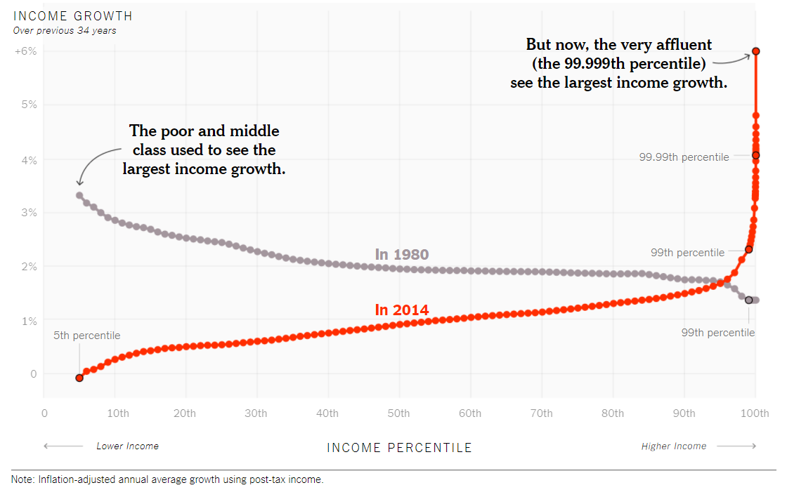
Figure 1. published in the New York Times, https://www.nytimes.com/interactive/2017/08/07/opinion/leonhardt-income-inequality.html?ref=opinion Data Source: Thomas Piketty, Emmanuel Saez and Gabriel Zucman. Charts by Jessica Ma and Stuart A. Thompson

[astroturfing] https://en.wikipedia.org/wiki/Astroturfing

[Bardon] Adrian Bardon, https://www.livescience.com/coronavirus-science-denial.html?utm_source=notification

[Dana] technical committee to the GCC Board from Gregory Dana (tech VP), January 18, 1996, and leaked to the N. Y. Times in 2009 http://www.sourcewatch.org/images/8/82/GCC_Primer_Draft.pdf

[Feynman] “Science is a way of trying not to fool yourself. The first principle is that you must not fool yourself, and you are the easiest person to fool.” Richard Feynman, from lecture “What is and What Should be the Role of Scientific Culture in Modern Society”, Galileo Symposium in Italy, 1964

[Friedman] Milton Friedman, The Methodology of Positive Economics, in Essays in Positive Economics, Chicago: University of Chicago Press, 1953, pp. 3-43.

[GCC] https://en.wikipedia.org/wiki/Global_Climate_Coalition

[Gilens] Martin Gilens and Benjamin I. Page, Testing Theories of American Politics: Elites, Interest Groups, and Average Citizens, Fall 2014, Perspectives on Politics, on line April 9, 2014

[inequality] https://inequality.org/billionaire-bonanza-2020-updates/

[Kahneman] Daniel Kahneman, Thinking Fast and Slow

[Oreskes] Naomi Oreskes and Erik M. Conway, Merchants of Doubt: How a Handful of Scientists Obscured the Truth on Issues from Tobacco Smoke to Global Warming, Bloomsbury Press, 2010

[Noerpel – 1] https://blueridgeleader.com/looking-for-skepticism-conclusion/

[Noerpel – 2] https://blueridgeleader.com/defending-the-over-pampered/

[Smith] Adam Smith, An Inquiry into the Nature and Cause of the Wealth of Nations, vol. 1, pt. xi, p.10 (at the conclusion of the chapter) (1776).

