What are we trying to do?

“Prepare for the worst and hope for the best.” Lee Childs

Tony Noerpel

At the October 8th Climate Action Webinar, hosted by Chair Randall and Supervisor Turner, one attendee asked a profoundly important question: “What is the lifetime emissions budget remaining for each Loudoun County resident?” Frankly, if we do not know this, we cannot determine any meaningful policy. We know there are some good things to do: more efficient light bulbs, more recycling and more rooftop solar, etc. but without a carbon budget, we may be making things even worse [Note]. We need to understand what we are trying to achieve and the scale of the problem, and then determine policy to achieve that. Conceptually, this is not hard to do. We only have to solve three simple equations.

The world community has adopted a goal of keeping the temperature anomaly increase relative to the pre-industrial climate to less than 2 degrees C. Temperature anomaly relates the current temperature at a time and place to the temperature at that same time and place averaged over a specified period. Thus, we compare the October temperature in Loudoun County with the temperature averaged over the period 1880 to 1910 in October and in Loudoun County. You can find a better explanation here [ete].

Currently, the atmosphere contains 415 parts per million by volume of carbon dioxide. In order to stay under 2 degrees C we need to not exceed an atmospheric carbon dioxide limit (AC limit) defined by this equation:

AC limit = 278 X e ^ (2 X ln(2) / ECS)

Both sides of this equation have the dimension in parts per million by volume (ppmV). The only parameter we need is the equilibrium climate sensitivity (ECS). By convention this is defined as how much the earth surface will warm if the atmospheric carbon dioxide level is doubled, which explains why we need the natural log of 2 in the equation. Both the “2” and ECS have dimensions of “degrees C” which cancel so we are taking the exponent of a dimensionless number. If we subtract 415 ppmV, the current carbon dioxide load, from the computed AC limit we get the remaining budget for emissions in terms of atmospheric carbon dioxide or by how much we can raise the atmospheric carbon dioxide content and still stay under 2 degrees C. The next simple equation translates this into carbon emissions measured in billions of tons of carbon [Note]. The global carbon emissions budget (GCEB) is:

(AC limit – 415) X 2.13 X 2 = GCEB

The 2.13 factor is a conversion term from ppmV atmospheric carbon dioxide to billions of tons of carbon emissions (GtC) [CDIAC]. The “2” factor recognizes that approximately 50% of our emissions are reabsorbed by the oceans and forests. To calculate the remaining carbon budget for Loudoun County residents, we only have to divide the global carbon emissions budget by the total population of humans in billions of people and then multiply by the population in Loudoun County:

GCEB X Loudoun County population / world population = Loudoun county carbon emissions budget.

We can use these three equations in the other direction starting with policy and determining its impact on the climate. OK, this is all pretty easy and straightforward except for the details, which is why to do this right we really need scientists’ very complex climate models and supercomputers. Conceptually, though these three simple equations lead to an understanding of the uncertainties and to the following questions:

Is 2 degrees C the appropriate temperature anomaly target? It is the de facto standard [carbon brief] because presumably the biosphere can tolerate this much warming and it leaves the climate short of tipping into a new state. But we have likely already crossed several thresholds: tropical coral reef survival, Arctic Ocean ice sheet and the Greenland ice sheet stability so it is not clear that this is the appropriate limit.

What is the value of ECS?

What about other greenhouse gases? We really need carbon dioxide equivalent values for emissions to account for nitrous oxide, methane and other greenhouse gases. We also have to account for carbon emissions from cement manufacture and from land-use changes in addition to emissions from fossil fuel combustion. The IPCC and National Climate Assessment reports all do this, of course, and a fuller explanation can be found here [esrl].

What about natural carbon cycle feedback emissions? When we warm the planet surface, permafrost will disintegrate leading to additional emissions of greenhouse gases (GHG). Forest fires are becoming larger and more frequent which will also release GHGs. Carbon is also being released from the disintegration of methane clathrate in the Arctic ocean sediments as the oceans warm.

And then of course, what about clouds, aerosols, albedo, ocean heat absorption and a whole host of other complexities? And what about fairness?

But let’s first focus on ECS

Zeke Housefather wrote a good explanation of climate sensitivity which explains the difference between Transient Climate Response (TCR) and Equilibrium Climate Sensitivity (ECS) [Housefather]. TCR is how much the Earth surface will warm if atmospheric carbon dioxide were to double but before the oceans and the atmosphere have equilibrated. Equilibration takes decades to centuries as the oceans are a vast heat sink. Earth radiation remains out of balance until the oceans have adjusted to the new level of carbon dioxide.

According to Housefather, we are currently experiencing TCR warming. There is uncertainty associated with the cooling effect of aerosols and the warming effect of other greenhouse gases such as methane and nitrous oxide but according to IPCC AR4 these two effects are approximately equal and therefore, we might take the current warming as due to the TCR of carbon dioxide alone. IPCC AR5 (2013) does not make this assumption but it is close enough. Using this assumption, since we’ve warmed the surface globally 1.2 degrees above the 1880-1910 average [NASA GISS] and atmospheric carbon dioxide has increased from 278 parts per million by Volume (ppmV) to 415 ppmV calculating TCR is straightforward and equal to 2.1 degrees C for all components and 1.5 due to the carbon dioxide alone. As we can see from Figure 1 [Schmidt], all negative forcings balance out the forcing due to methane and nitrous oxide but not the other GHGs.

According to a recent paper by Sherwood et al. the new estimate for ECS is between 2.6 and 3.9 degrees C in the “likely” range [Sherwood]. This is shown in Figure 2. Therefore, the difference between TCR and ECS is between 0.5 and 1.8 degrees C with a median value of 1.15 degrees C. We can reasonably assume, based on ECS, that we have effectively warmed the surface by between 1.7 degrees C and 3 degrees C after the ocean-atmosphere equilibration.

There are two additional concerns I have with this. We know that aerosols wash out of the atmosphere fairly quickly. We saw this in 1992. Mount Pinatubo erupted in 1991 and as a consequence 1992 and 1993 were relatively cool years but 1995 was the warmest year on record up to that time because the aerosols from the volcano had already washed out. It is reasonable to assume that if we were to quit burning fossil fuels cold turkey, the same thing would happen. The current content of aerosols would wash out in a few years leaving us with the warming due to methane and nitrous oxide. This phenomenon is called “global dimming” [wiki]. Aerosols may be masking between 0.25 and 1.1 degrees C of additional warming due to other greenhouse gases and this may be in addition to the difference between TCR and ECS for atmospheric carbon dioxide carbon dioxide [Lelieveld]. Therefore, the planet may already be committed to between 1.95 degrees C and 4.1 degrees C warming. In other words, there may no longer be an emissions budget for 2 degrees of warming if we account for other GHGs and the dimming effect of aerosols.

The second concern I have is that currently, almost half of the models are showing a much higher value of ECS between 4 and 6 degrees C as shown in Figure 1. One of these models, [Gettelman] estimates ECS equal to 5.3 degrees. These high values are frightening and hard to believe but as shown in Figure 3, the Gettelman model hindcasts the past climate quite accurately. Can all of these values be correct?

Maybe. A new paper by Anagnostou et al. concludes that climate sensitivity is state dependent and much higher in a warm climate of the Eocene than in a cool climate today [Anagnostou]. The difference may be attributable to how much ice is on the planet surface. It takes 333.55 kJ energy to melt 1 kg of ice without raising the temperature at all but that same energy would raise the temperature of liquid water 80 degrees C [water]. Thus, we might expect the climate sensitivity to be low where there is a lot of surface ice. Kristina Pistone and colleagues estimate that elimination of Arctic ice during the sunlit part of the year may be equivalent to 25 years of emissions at the current rate [Pistone] or about 273 GtC. We might expect four nonlinear climate tipping points. Within a few decades the Arctic will be ice free in both winter and summer [Guarino] [Polyakov]. Within a few centuries, Greenland will be ice free [King] [Sasgen]. Subsequently, West Antarctica may lose its glaciers and finally, if we persist in burning fossil fuels, the great Antarctic ice sheet will disappear. All of this ice took tens of millions of years to develop as the Earth grew colder during the entire Cenozoic, the last 66 million years. This reminds me of something James Hansen wrote years ago. Building glaciers is a dry process and takes a long time. Melting glaciers is a wet process and happens much faster. With our emissions and other misbehavior, we may be winding the clock back millions or tens of millions of years within a few centuries.

I’m not a climate scientist and am doing a lot of handwaving here and perhaps some double booking on the one hand. On the other hand, all of the plans to keep the climate below 1.5 degrees require negative emissions and most of the plans for 2 degrees also require negative emissions which is to say we’ve likely already blown the 2-degree budget.

To be continued

[Note] As a cautionary observation: in the last forty years humanity has made the most remarkable strides in energy efficiency in all of our myriad appliances and yet emissions have gone up. This phenomenon was even predicted by the engineer William Jevons in 1865 in his paper “The Coal Question” [Jevons]. Economists call this direct and indirect rebound effect on consumption. We experience the direct effect as consumers when we leave the lights on in a room because we’ve replaced the light bulbs with more efficient ones, using even more total energy, we are less concerned. And indirectly if we save enough money on gasoline driving a fuel-efficient car that we can afford to fly somewhere on vacation increasing our total emissions. Clearly, efficiency gains may not work to limit future emissions because they never have before. The real lesson is that any policy may not actually have the intended consequences.

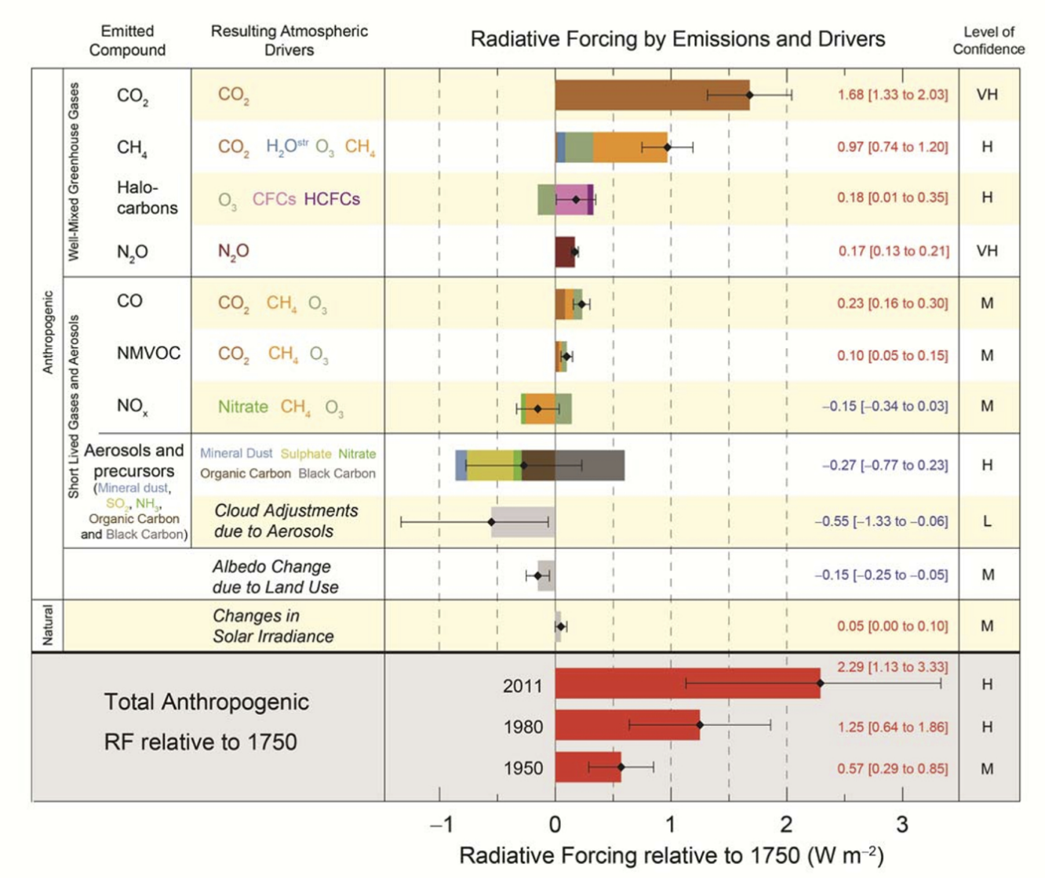
Figure 1. Radiative forcings estimates from IPCC AR5 (2013).

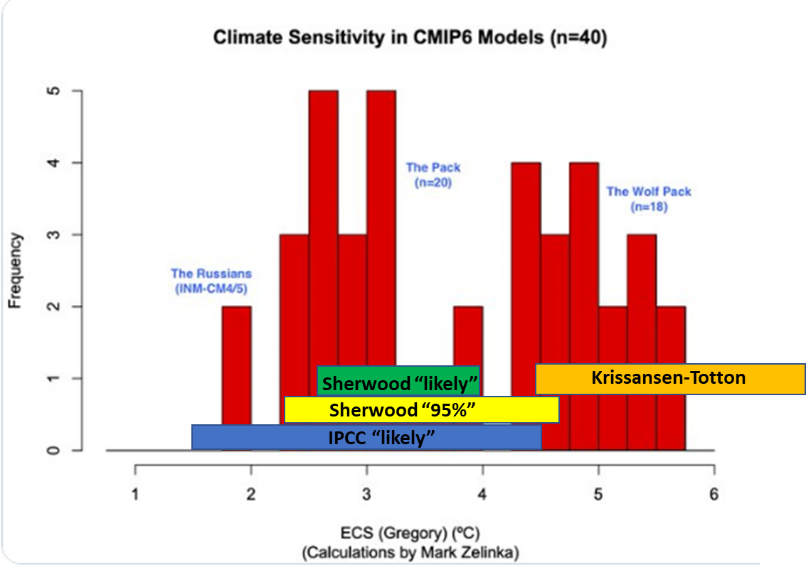
Figure 2. Equilibrium Climate Sensitivity in the climate models being used for the next IPCC AR6 report. The “Pack” of 20 models are clustered around 3 degrees and agree with the IPCC “likely” consensus. The “Wolf Pack” or 18 models however are computing a marked increase of about 2 degrees over the “Pack”. This is disconcerting. [Sherwood] is an estimate of ECS based on paleoclimate observation and the recent warming, i.e., it is relevant to an ice age climate. [Krissanses-Totton] is based on paleoclimate observations during the last 100 million years and may be more appropriate for a warm or hot house climate. Source for climate model estimates [Schmidt].

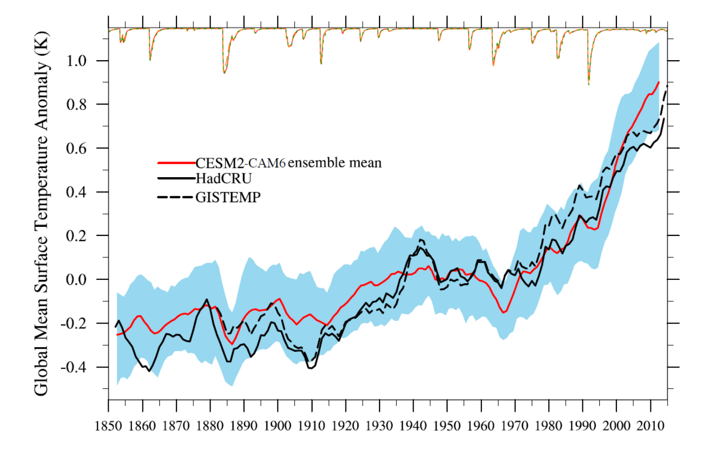
Figure 3. Comparison of the actual global temperature anomaly with the hindcast produced by the Community Earth System Model Version 2 (CESM2) [Getterman]. Source: grl59336-sup-0001-2019GL083978-Text_SI-S01.pdf

[Anagnostou] E. Anagnostou, E. H. John, T. L. Babila, P. F. Sexton, A. Ridgwell, D. J. Lunt, P. N. Pearson, T. B. Chalk, R. D. Pancost & G. L. Foster, Proxy evidence for state-dependence of climate sensitivity in the Eocene greenhouse, Nature Comm., 2020, https://doi.org/10.1038/s41467-020-17887-x

[carbon brief] https://www.carbonbrief.org/two-degrees-the-history-of-climate-changes-speed-limit

[cdiac] https://cdiac.ess-dive.lbl.gov/pns/convert.html

[esrl] https://www.esrl.noaa.gov/gmd/aggi/aggi.html

[ete] http://ete.cet.edu/gcc/?/globaltemp_anomalies/

[Gettelman] Gettelman, A., Hannay, C., Bacmeister, J. T., Neale, R. B., Pendergrass, A. G., Danabasoglu, G., et al. (2019). High climate sensitivity in the Community Earth System Model Version 2 (CESM2). Geophysical Research Letters, 46. https://doi.org/10.1029/2019GL083978

[Guarino] Maria-Vittoria Guarino, Louise C. Sime, David Schröeder, Irene Malmierca-Vallet, Erica Rosenblum, Mark Ringer, Jeff Ridley, Danny Feltham, Cecilia Bitz, Eric J. Steig, Eric Wolff, Julienne Stroeve and Alistair Sellar, Sea-ice-free Arctic during the Last Interglacial supports fast future loss, Nature Climate Change, 10 August 2020, https://doi.org/10.1038/s41558-020-0865-2

[Housefather] https://www.carbonbrief.org/explainer-how-scientists-estimate-climate-sensitivity

[Jansen] Eystein Jansen, Jens Hesselbjerg Christensen, Trond Dokken, Kerim H. Nisancioglu, Bo M. Vinther, Emilie Capron , Chuncheng Guo, Mari F. Jensen, Peter L. Langen, Rasmus A. Pedersen, Shuting Yang, Mats Bentsen, Helle A. Kjær, Henrik Sadatzki, Evangeline Sessford and Martin Stendel, Past perspectives on the present era of abrupt Arctic climate change, Nature Climate Change, Vol. 10, August 2020, https://doi.org/10.1038/s41558-020-0860-7

[Jevons] https://en.wikipedia.org/wiki/Jevons_paradox

[King] Michalea D. King, Ian M. Howat, Salvatore G. Candela, Myoung J. Noh, Seonsgu Jeong, Brice P. Y. Noël, Michiel R. van den Broeke, Bert Wouters and Adelaide Negrete, August 13, Dynamic ice loss from the Greenland Ice Sheet driven by sustained glacier retreat, Nature Comm. Earth & Env., (2020), https://doi.org/10.1038/s43247-020-0001-2

[Lelieveld] J. Lelieveld, K. Klingmüller, A. Pozzer, R. T. Burnett, A. Haines, and V. Ramanathan, Effects of fossil fuel and total anthropogenic emission removal on public health and climate, PNAS April 9, 2019 116 (15) 7192-7197; https://doi.org/10.1073/pnas.1819989116

[NASA-GISS] https://data.giss.nasa.gov/gistemp/tabledata_v4/GLB.Ts+dSST.txt

[Pistone] Pistone, K., Eisenman, I., & Ramanathan, V. (2019). Radiative heating of an ice-free arctic ocean. Geophysical Research Letters, 46, 7474–7480. https://doi.org/10.1029/2019GL082914

[Polyakov] Igor Polyakov et al., Weakening of Cold Halocline Layer Exposes Sea Ice to Oceanic Heat in the Eastern Arctic Ocean, 15 September 2020, https://doi.org/10.1175/JCLI-D-19-0976.1

[Sasgen] Ingo Sasgen, Bert Wouters, Alex S. Gardner, Michalea D. King, Marco Tedesco, Felix W. Landerer, Christoph Dahle, Himanshu Save & Xavier Fettweis, Return to rapid ice loss in Greenland and record loss in 2019 detected by the GRACE-FO satellites. Commun Earth Environ 1, 8 (2020). https://doi.org/10.1038/s43247-020-0010-1

[Schmidt] http://www.realclimate.org/index.php/archives/2013/10/the-evolution-of-radiative-forcing-bar-charts/

[water] https://en.wikipedia.org/wiki/Enthalpy_of_fusion

[wiki] https://en.wikipedia.org/wiki/Global_dimming

