What went wrong with economic theory

“Truly important and significant hypotheses will be found to have assumptions that are wildly inaccurate descriptive representations of reality and, in general, the more significant the theory, the more unrealistic the assumptions.” Milton Friedman [Friedman]

Tony Noerpel

Milton Friedman proposed a theory of firms which was based on false assumptions. When this was pointed out to him, rather than do the mea culpa, he wrote the text cited above [Friedman]. As a matter of fact, the only conclusions one can draw from assumptions “that are wildly inaccurate descriptive representations of reality” are themselves “wildly inaccurate descriptive representations of reality”. So why didn’t the economics community relegate him to the dustbin of economic trivia instead of giving him their highest honor, the Economics Nobel? He concluded that corporations shouldn’t be taxed, labor and consumer unions were bad but corporate unions or unions of capital were good and regulation of business interests was a bad thing, even with respect to worker safety, consumer safety and protection of the environment. All of his conclusions were wildly inaccurate descriptive representations of reality but appealing to elites. Corporations and billionaires funded him and the Chicago School of Economics, which has the distinction among all the various economic ideologies of supporting Pinochet and other dictators, because democracy was bad for business. Sadly, wealth and power have corrupted the economic discipline to the point where many economists like many large multinational corporations, billionaires, politicians and pundits have been denying the structural problems which are destroying humanity specifically climate change, biodiversity loss and wealth and power inequality.

As we saw last week, mainstream economic theory or neo-classical or the Chicago School of economics has a flawed production function which ignores thermodynamic reality. These economists assume that labor and capital are factors of production and ignore energy. This leads them to the false conclusion that energy consumption is a consequence of economic activity rather than that a flow of energy created by dissipating an energy gradient causes economic activity. This further leads them to believe that energy is limitless and that resources are infinite on a finite planet. They have invented a theory of infinite substitution which says that whenever civilization nears a limit in one resource, there will always be some other resource we can substitute for it and so we will never run out of anything [Bardi]. This, they claim, is because there are price signals which inform the economy to switch to a more expensive resource when the original resource approaches a limit and becomes too expensive. This is bumpkus.

Economists in this school also ignore entropy. Entropy is essentially pollution which does not go away and generally degrades the environment or the ability of Earth to support life. Economists label these things externalities so that they can ignore them. Marine biologist and writer Carl Safina observes [Safina]: “No one will need to colonize Mars. It will be dead enough right here.” Nature has evolved to recycle waste through the biosphere. We humans overwhelm that system with more waste than can be properly recycled within any time span relevant to humanity or the biosphere including carbon dioxide and other greenhouse gases in the atmosphere, plastics in the ocean, agricultural chemicals in rivers and estuaries, landfills, radioactive nuclear power plant waste, mining waste, electronic waste [E waste] and much more. Since the consequences of human-produced entropy is the sixth extinction, it is a big deal and renders neo-classical economics completely useless to the survivability of humanity. As a reminder:

Production = maintenance + growth + waste = (normalizing constant x inefficiencies) / (1-feedbacks) x (energy flows – irreversibility)

Every economic process is irreversible, inefficient, produces waste and currently more than 90% of production is being used to maintain existing wealth, i.e., wealth that has deteriorated to waste. All this is entropy and not a bit of it is external to the human economy or the fragile biosphere we inhabit.

The most widely used undergraduate text book on economics by N. Gregory Mankiw [Mankiw] does not have a listing for entropy in its index and its only description of energy is as just another commodity. He also models the economy as a perpetual motion machine with money flowing in one direction and goods and services flowing in the other with no inputs or outputs as if money had motive force [Mankiw, p. 23 and 509]. However, as historian Yuval Harari reminds us, money has no physical reality. Whales, bees, earthworms, trees and planets do not move on money. They do not recognize money as value any more than does God or nature. Money is a human myth we tell each other and share. We accept money for stuff because we trust the government to defend the value of the coin of the realm so that we can exchange it for some other stuff later. But money is a story that on occasion we stop believing, causing bank runs and economic collapses. What moves and transforms stuff, from planets to bacteria is energy. There are two definitions of wealth. Real wealth is physical stuff and imaginary wealth is money. Real stuff is a product of thermodynamic power or the flow of energy. Money, while useful in moderation, represents the power of one human over another in the extreme. Economist Adam Smith reminds us [Smith] wealth equals power; and a powerful positive feedback loop exists between wealth concentration and power concentration. This has been true throughout human history.

Engineer, economist and demographer Vilfredo Pareto’s elegantly simple yard sale model of a free market economy shows that wealth always concentrates naturally with one economic agent eventually accumulating all of the wealth [Noerpel, 2011]. The winning agent is random. In other words, most of wealth accumulation is pure dumb luck. This explains the difference in wealth between President Trump and children who are born, will live out their entire lives and die on a landfill (see Figure 1). In the mind of a conservative economist, Trump’s stollen wealth (I assume that is why he is fighting so hard to keep his tax filings secret) will trickle down to these children in the same way our electronic waste trickles down and ends up on a landfill just like this one where children like this can find it and expose themselves to toxic chemicals recycling the gold and other metals for a little bit of a crumb to eat [Obusan]. Of course, these children do not need access to education or health care or lawyers to help them out of their misery since if they had any gumption or would work as hard as Trump does cheating at his golf game [Schwartz], or “find something new” like Ivanka [Sinclair]. They could use their entrepreneurial talents, economist will tell us, to pull themselves up by their own boot straps, if only they had boots.

Figure 2 shows the cumulative distribution [Noerpel, 2019] of wealth in America as of 2016 [Li]. It shows exactly what Pareto’s model predicts. Wealth is being accumulated by a vanishingly small number of people faster than wealth is being created [Piketty] so it has to come at the expense of the working poor and the middle classes. Soon if not already, we will only be producing maintenance and waste and the economy will be permanently shrinking and yet extreme wealth will continue to grow and that is when the middle class slips into poverty, then destitution and then slavery, unless we stop that from happening now. Our billionaires already control more wealth than 94% of the rest of the population which means we live in an oligarchy and not a democracy.

This is all nicely demonstrated by the current COVID-19 pandemic. Between March 18 and June 19, 2020, the richest 643 Americans increased their wealth from $2.948 trillion to $3.531 trillion, an increase of $584 billion [inequality] or 106% compounded annually during a period when the economy contracted. This wealth extraction resulted in nearly 50 million Americans filing for unemployment as of July 11 [Goldman] and more than 137,000 dying from COVID-19 [Glenza] mostly due to Trump’s incompetence [Sebenius] and his psychopathy [Greenwood] but also enabled by conservative economists. These statistics are all related [Thorbecke]. Yet San Francisco Federal Reserve President, economist, and Trump-enabler, Mary Daly defended the U.S. central bank from criticism that its easy monetary policy and emergency lending programs are doing more to help the rich than the poor [Saphir]. Is Daly clueless or a scoundrel?

That makes three hard economic laws which economists need to reintroduce into their theories: energy flow is the only factor of production; entropy is not an externality but an integral part of the economic system; and extreme wealth equals extreme power and represents a powerful positive feedback loop. All is not lost as many economists have already done this for us. We just need to find the right economists.

To be continued.

Figure 1. The difference between President Donald Trump and these children is pure dumb luck, emphasis in this case on dumb. “A young scavenger boy grabs plastic between tons of trash in the Anlong Pi landfill on June 11, 2014 in Siem Reap, Cambodia. Dozens of children scavenge every day in the Anlong Pi landfill, which is situated only few kilometres away from the world famous Angkor temples, visited by more than 3 million tourists every year. (Getty)” Source: https://childrenofthelandfill.com/children-living-on-a-landfill/

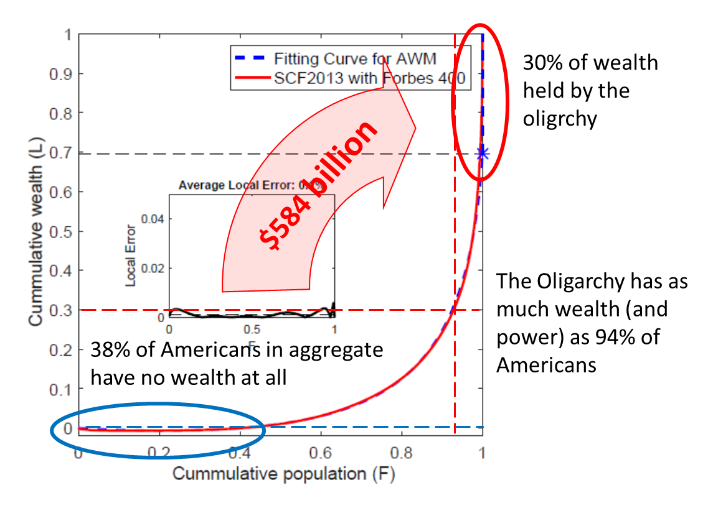
  - Figure 2. Wealth distribution in America as of 2016 adapted from [Li]. Since that time more wealth has been extracted from the middle class and working poor by the oligarchy and the $584 billion is just what they’ve extracted during the COVID-19 pandemic between March 19 and June 18 [Inequality]. I’ve added the red oval and the black dashed line to indicate the wealth controlled by the oligarchy and the blue oval to indicate the 38% of the population which in aggregate has no wealth (the dashed blue line) and the red dashed lines to indicate the total population which owns as much wealth as the oligarchy.

[Bardi] Ugo Bardi, Limits to Growth Revisited.

[E waste] https://globalewaste.org/

[Friedman – 1] Milton Friedman, The Methodology of Positive Economics, in Essays in Positive Economics, Chicago: University of Chicago Press, 1953, pp. 3-43.

[Glenza] https://news.yahoo.com/coronavirus-death-rate-isnt-why-070014351.html

[Goldman] https://www.thestreet.com/markets/jobless-claims-unemployment-benefits-jobs-economy-labor

[Greenwood] https://medium.com/@vgwcct/a-duty-to-differentially-diagnose-the-validity-underpinning-the-diagnosis-of-the-president-371354142a02

[inequality] https://inequality.org/billionaire-bonanza-2020-updates/

[Li] Jie Li, Bruce M. Boghosian, and Chengli Li, The Affine Wealth Model: An agent-based model of asset exchange that allows for negative-wealth agents and its empirical validation, 2018, https://arxiv.org/abs/1604.02370v2

[Mankiw] N. Gregory Mankiw, Principles of Economics, 4th ed.,

[Noerpel, 2011] January 18, 2011, https://blueridgeleader.com/yard-sale-part-1/
January 25, 2011, https://blueridgeleader.com/yard-sale-part-2/
March 8, 2011, https://blueridgeleader.com/yard-sale-part-3/

[Noerpel, 2019] https://blueridgeleader.com/the-rich-and-the-poor/
https://blueridgeleader.com/cumulative-wealth-and-gini-explained/

[Obusan] https://childrenofthelandfill.com/

[Piketty] Thomas Piketty, Capital in the Twenty-First Century, Harvard University Press, 2013.

[Safina] Carl Safina, Becoming Wild, how animal cultures raise families, create beauty, and achieve peace, Henry Holt, 2020, p. 109.

[Saphir] https://uk.reuters.com/article/us-usa-fed-daly/fed-isnt-fueling-u-s-inequality-daly-says-idUKKBN23U2DH

[Schwartz] https://gen.medium.com/the-psychopath-in-chief-aa10ab2165d9

[Sebenius] https://www.statnews.com/2020/06/19/faster-response-prevented-most-us-covid-19-deaths/

[Sinclair] https://boingboing.net/2020/07/14/ivanka-tells-18-million-out-of.html

[Smith] Adam Smith, The Wealth of Nations, Book 1, Chapter 5, 3rd paragraph, 1776, Bantam Classic Edition, 2003.

[Thorbecke] https://abcnews.go.com/Business/extreme-inequality-preexisting-condition-covid-19-widened-americas/story?id=71401975

