When we cross 1.5 degrees for good

“continuing on our current path will lead to catastrophic changes to the Earth system that give us life.” Peter Kalmus

“We climate scientists have … concluded, unequivocally, that global warming is caused by humans burning fossil fuels, although we continue to understate the urgency and seriousness of the threat… we have nonetheless delivered our message. How humanity acts on that message is up to the policymakers, which really just means it’s up to people like you.” Peter Kalmus [Kalmus]

Tony Noerpel

People like you and me dear reader. It is up to us and we are all variously climate activists, policy makers, engineers, planners, advocates, parents, grandparents and citizens who are trying to design, support and implement policy to both mitigate a climate crisis and adapt to it based on the evidence presented to us by science. Unfortunately, there is a large range of possible outcomes because there is considerable uncertainty in future emissions, and in how sensitive the Earth system climate is to greenhouse gas emissions as reported in the scientific literature. While it is prudent to develop a plan for the worst-case scenarios, we may instead want to implement policies which at least address the majority of the probability space. There is some argument against harming the economy by implementing a plan which is “too” aggressive, but since the economy features an extremely strong positive feedback loop between wealth and power, it is highly unstable and likely to collapse without a severe wealth tax anyway regardless of what climate mitigation plan we implement, and it therefore doesn’t make much sense to worry about being too aggressive. In any event in the worst-case scenarios the economy is irrelevant since civilization collapses and humanity goes extinct. The only danger in adopting overly aggressive emissions cuts would seem to be that we make a better world for nothing. At any rate it seems prudent to bound the possible outcomes by defining the best of all possible worlds as well as the worst-case forecasts.

A new estimate for equilibrium climate sensitivity published in the journal Climate Dynamics by climate scientists Raphaël Hébert, Shaun Lovejoy, and Bruno Tremblay does define the best possible scenario [Hébert]. Their estimate is on the low side of IPCC estimates and is shown in Figure 1. Even though this estimated climate sensitivity is low, the authors still forecast that the climate will pass the 1.5 K Paris Accord target sometime between 2027 and 2042, which means in reality we will likely cross it sooner. In so far as adaptation and mitigation planning is concerned their estimate of climate sensitivity is too optimistic as the authors point out. They justify their forecast by pointing out that: “Climate skeptics have argued that IPCC projections are untrustworthy precisely because they are entirely (General Circulation Model) GCM based. While this conclusion is unwarranted, it underscores the need for independent and qualitatively different approaches. It is therefore significant that the alternative GCM-free approach we present here yields comparable results albeit with smaller uncertainty.” Since their mathematical model is based on optimistic assumptions, as they admit, it plausibly defines the best possible outcome and would presumably be more digestible for skeptics.

However, if we define a skeptic as someone who has an evidence-based testable objection and who is also willing to be wrong then there are no longer any climate crisis skeptics. There is nobody who is going to be convinced by the [Hébert] conclusions any more than they have already been convinced by the vast accumulation of science which has already preceded it. It is just another nail in the denier coffin which is already hemorrhaging nails. Nonetheless, for those of us looking for a best-of-all-possible-worlds scenario to bound the problem, the paper’s conclusions are very helpful.

The mathematical model the authors use is linear. They state: “our model has obvious limitations since it assumes a linear stationary relationship between forcing and temperature, neglecting nonlinear interactions which could arise as the system evolves, as it currently warms. In particular, so-called tipping points could be reached in the coming century which would lead to a breakdown of the linear model proposed.” Given the stated purpose of the analysis to convince “skeptics” that human-caused climate change is real, this is the appropriate thing to do because including potential nonlinear effects could leave any conclusions subject to further skeptical scrutiny or denier rejection. Unfortunately, we are soon to cross several tipping points within years and decades, including tropical coral reef loss [Note], loss of Arctic sea ice and permafrost decomposition. The Arctic Ocean is expected to be ice-free by around 2035 [Guarino]. The reflectivity of open water compared to ice in this ocean adds the equivalent of about 1,000 billion tons of additional carbon dioxide to the radiation budget [Pistone], or the equivalent of about 57 parts per million by volume which is not accounted for either in the IPCC AR5 or in [Hébert] as this additional forcing is outside the scope of their model.

Carbon cycle feedbacks are also outside the scope of the authors’ model and not accounted for in the IPCC AR15 budgets [Anderson] yet a new study estimates that even if all emissions, including those from agriculture cease, future permafrost emissions ensure the climate warms to 2.6 C over 1850 [Randers]. The [Randers] estimate is controversial within the climate science community but future permafrost emissions are certainly not zero. Schwalm et al. estimate total carbon cycle feedbacks between 150 and 500 billion tons of carbon emissions up to 2100, adding between 8 and 28 ppmv to the atmosphere [Schwalm]. In any event, it seems that tipping points are a feature of Earth’s climate system and it would be hard to argue against the possibility of something like the Dansgaard–Oeschger (D–O) events described by [Jansen] occurring due to the magnitude of the perturbation we’ve already caused and the relevant fact that D-O events did happen, repeatedly.

The model is strictly limited to an ice house climate and does not account for the possibility of transitioning to a coolhouse or Miocene climate (see [Westerhold]). The authors point out that: “There is evidence that the climate sensitivity depends on the mean climate state and therefore the modern ECS does not necessarily correspond to past ECS.” And “Our method is strictly based on modern instrumental data and the low uncertainty could be an ‘epoch bias’, i.e. if climate sensitivity depends on the climate mean state, then an estimate based on only one period would not necessarily be representative.”

Surface albedo from land use changes is left out of the model yet the total biomass of plants has been reduced since the invention of agriculture from about 2 teratonnes to 1 teratonne as forests, wetlands and prairies have been replaced by 0.1 teratonne of agricultural plants and by buildings [Elhacham] [Pappas]. Replacing lush forests with crops and empty winter fields increases the albedo of the Earth surface, cooling the planet and thus masking the real sensitivity of the climate to greenhouse gases.

Carbon emissions budgets for different ECS values and for several warming targets are shown in Figure 2. Currently, the level of atmospheric carbon dioxide is 415 parts per million by volume but carbon dioxide equivalent, which accounts for other greenhouse gases is already 500 parts per million by volume [NOAA]. Both values are well outside the ice house regime we are currently in, suggesting a state change to a hotter climate regime such as the early Miocene may be already unavoidable [Westerhold].

In Table a) I calculate the budgets for various values of ECS and for several target climates while ignoring other greenhouse gases besides CO2, carbon cycle emissions and Arctic sea ice melt. We can see that even for a relatively low ECS of 2.6 degrees per doubling of atmospheric carbon dioxide there is no budget left to avoid a 1.5-degree world. And in fact, in b) we see that carbon cycle emissions and an ice-free Arctic, eat away the entire carbon budget even for the lowest likely value for ECS of 2 degrees.

Finally, accounting for other greenhouse gases in table c) there is no budget left for even a 2-degree world assuming an ECS of 2 degrees. And if climate sensitivity turns out to be somewhere in the middle of probability space such as 3.25 degrees, we see we are heading for a 3-degree world, i.e., somewhere between a manageable disaster and a catastrophe.

The best any nation is proposing to do is to achieve zero carbon emissions by 2050; and these are more aspiration than actionable plans [Darby]. If every nation achieved this goal, atmospheric CO2 increase would be limited to around 31 ppmV. Adding all these contributions up and accounting for the current 500 ppmV carbon dioxide equivalent, we get 607 ppmV. This much carbon dioxide equivalent will warm the planet 3 K assuming an ECS of 2.6 degrees which is on the likely low end based on [Sherwood].

Every proposed scenario to stay under 1.5 or 2 degrees of warming uses transient climate response rather than ECS and also assumes negative emissions. I guess if one assumes, we can pull carbon dioxide out of the atmosphere faster than its effect on Earth’s temperature manifests there will only be a transient response.

What all this means is that we should have a plan to adapt to a 5-degree warmer world and hope we never have to implement it. We need to consider that an ECS of 5 degrees is possible, even if not likely [Bjordal]. We should implement a plan that reduces greenhouse gases as fast as possible and adapts to at least a 3-degree world. This includes the agricultural sector which is now responsible for about 30% of emissions. Most importantly, we have to stop killing off the biosphere which means we should not count on negative emissions schemes, which all have negative environmental penalties besides the nagging suspicion that they probably will not actually work. The climate scientist Peter Kalmus asked 60 climate scientists if they thought we would limit warming to below 2 degrees and 55 said “no” [Kalmus]. I think Kalmus is right to say that the climate science community has been understating the urgency. I don’t think it helps discussing 1.5 degrees warming as even a remote possibility. Given that 2020 ended with a la Nina and was during a solar minimum [Masters] and yet will likely be the warmest year on record beating the el Nino year of 2016, we have effectively warmed the planet by 1.3 degrees already. Those of us who are not climate scientists have to give equal weight to all of the reported legitimate science which includes the possibility that ECS is more than 5 degrees. And we should stop calling deniers “skeptics”.

[Note] According to NASA [NASA] and IPCC SR15 this tipping point has already tipped. According to a tipping point review paper by Seaver Wang and Zeke Hausfather [Wang] this is not a climate problem though it is a disaster biologically. Earth history informs us that biology has always played a dominant role in the evolution of Earth’s climate and will continue to do so. See for example [Shaltami]. Eliminating tropical coral reefs is such a big deal biologically that it will likely impact the Earth climate even if we humans do not yet fully comprehend how that might work out.

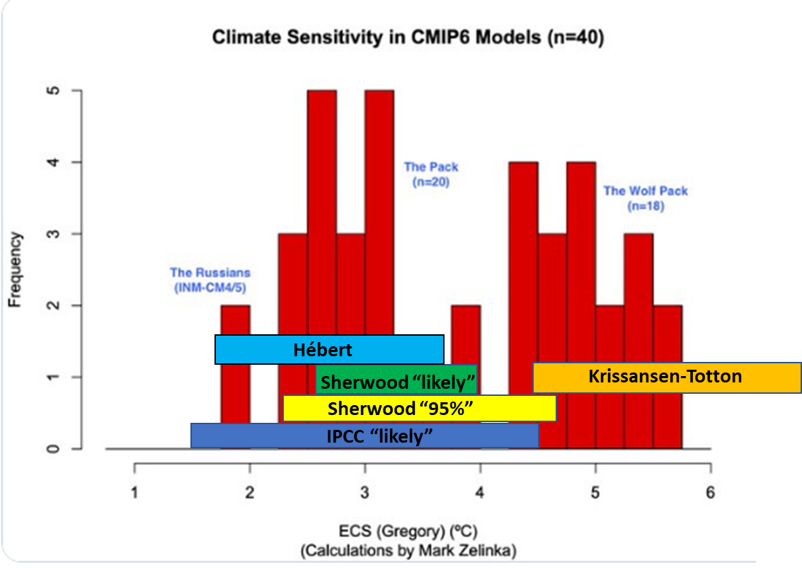
Figure 1, Equilibrium climate sensitivity estimates from several sources. Histogram of current IPCC CIM6 climate models (red) being used for the next IPCC AR6 report. The “Pack” of 20 models are clustered around 3 degrees and agree with the IPCC “likely” consensus. The “Wolf Pack” or 18 models however are computing a marked increase of about 2 degrees over the “Pack”. Estimate of ECS using a linear mathematical model of instrument record warming (light blue) [Hébert]. A combination of models, Pleistocene/Holocene climate since 22,000 ya (green) likely and (yellow) highly likely [Sherwood]. ECS reported in IPCC AR5 likely (dark blue). [Krissansen-Totton] is based on paleoclimate observations during the last 100 million years and may be more appropriate for a warm or hot house climate. Source for climate model estimates [Schmidt].

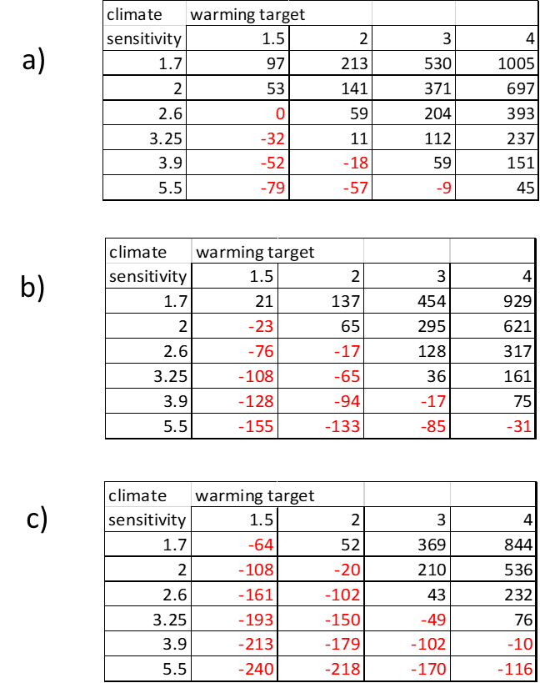
Table 1. remaining carbon budgets for several possible values of climate sensitivity which is defined as how much the Earth surface would warm with a doubling of atmospheric Carbon dioxide equivalent. 1.7 is the transient climate response from [Hébert]. 2 is the lowest possible value reported by [Sherwood]. 2.6 is the lowest “likely’ value in [Sherwood] which reports a highest “likely” value of 3.9 and a median value of 3.25. 5.5 is the mean value reported by (HadGEM3) [Zelinka] and 5.3 is the mean value reported by the Community Earth System Model Version 2 (CESM2) [Gettelman]. See also Bjordal et al. a) ignores other GHGs, permafrost and Arctic sea ice retreat. b) accounts for permafrost and Arctic blue ocean event. c) includes other GHGs.

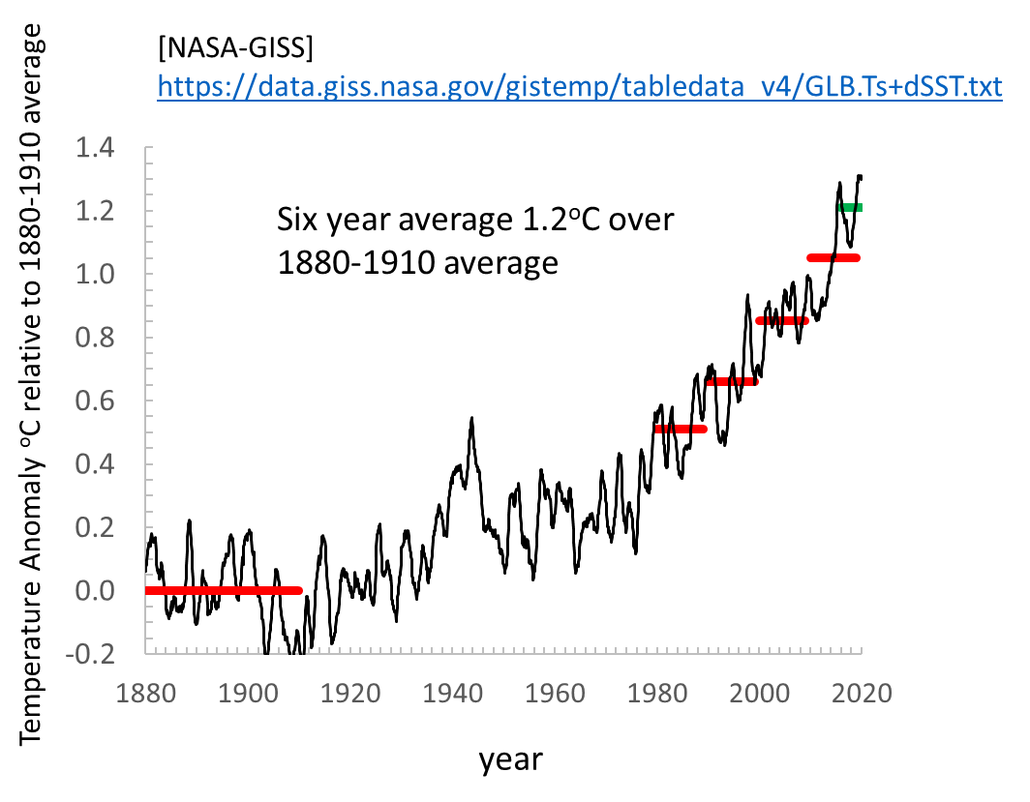
Figure 2. global earth surface temperature anomaly [NASA-GISS] through November, 2020. In this chart I use a twelve-month moving average and plot the result at the last month for each twelve-month period. Since May the twelve-month moving average has been over 1.3 degrees and above the peak in 2016 ending in September of 1.29 degrees. This is frightening because while 2016 was a strong el Nino, in 2020 a moderate La Niña event formed during a minimum in the solar cycle. 2020 should have been a relatively cool year [Masters].

[Anderson] Kevin Anderson , John F. Broderick & Isak Stoddard (2020): A factor of two:
how the mitigation plans of ‘climate progressive’ nations fall far short of Paris-compliant pathways,
Climate Policy, https://doi.org/10.1080/14693062.2020.1728209

[Bjordal] Jenny Bjordal, Trude Storelvmo, Kari Alterskjær and Tim Carlsen, Equilibrium climate sensitivity above 5 °C plausible due to state-dependent cloud feedback, Nature Geoscience, November, 2020, https://doi.org/10.1038/s41561-020-00649-1

[Darby] Megan Darby and Isabelle Gerretsen, updated 28 October, 2020, https://www.climatechangenews.com/2019/06/14/countries-net-zero-climate-goal/

[Elhacham] Emily Elhacham, Liad Ben-Uri, Jonathan Grozovski, Yinon M. Bar-On & Ron Milo, Global human-made mass exceeds all living biomass, Nature, 2020, https://doi.org/10.1038/s41586-020-3010-5

[Gettelman] Gettelman, A., Hannay, C., Bacmeister, J. T., Neale, R. B., Pendergrass, A. G., Danabasoglu, G., et al. (2019). High climate sensitivity in the Community Earth System Model Version 2 (CESM2). Geophysical Research Letters, 46. https://doi.org/10.1029/2019GL083978

[Guarino] Maria-Vittoria Guarino, Louise C. Sime, David Schröeder, Irene Malmierca-Vallet, Erica Rosenblum, Mark Ringer, Jeff Ridley, Danny Feltham, Cecilia Bitz, Eric J. Steig, Eric Wolff, Julienne Stroeve and Alistair Sellar, Sea-ice-free Arctic during the Last Interglacial supports fast future loss, Nature Climate Change, 10 August 2020, https://doi.org/10.1038/s41558-020-0865-2

[Hébert] Raphaël Hébert, Shaun Lovejoy, and Bruno Tremblay, An observation‑based scaling model for climate sensitivity estimates and global projections to 2100, Climate Dynamics, 18, December, 2020, https://doi.org/10.1007/s00382-020-05521-x

[Jansen] Eystein Jansen, Jens Hesselbjerg Christensen, Trond Dokken, Kerim H. Nisancioglu, Bo M. Vinther, Emilie Capron , Chuncheng Guo, Mari F. Jensen, Peter L. Langen, Rasmus A. Pedersen, Shuting Yang, Mats Bentsen, Helle A. Kjær, Henrik Sadatzki, Evangeline Sessford and Martin Stendel, Past perspectives on the present era of abrupt Arctic climate change, Nature Climate Change, Vol. 10, August 2020, https://doi.org/10.1038/s41558-020-0860-7

[Kalmas] Peter Kalmas, Being the Change, Live well and spark a climate revolution, New Society Publishers, 2017.

[King] Michalea D. King, Ian M. Howat, Salvatore G. Candela, Myoung J. Noh, Seonsgu Jeong, Brice P. Y. Noël, Michiel R. van den Broeke, Bert Wouters and Adelaide Negrete, August 13, Dynamic ice loss from the Greenland Ice Sheet driven by sustained glacier retreat, Nature Comm. Earth & Env., (2020), https://doi.org/10.1038/s43247-020-0001-2

[Krissansen-Totton] Joshua Krissansen-Totton, & David C. Catling, Constraining climate sensitivity and continental versus seafloor weathering using an inverse geological carbon cycle model, Nature Communications, 22 May 2017, https://doi.org/10.1038/ncomms15423

[Masters] Jeff Masters, and Dana Nuccitelli The top 10 weather and climate events of a record-setting year. In an all-around bizarre and largely unpleasant calendar year, extreme weather and climate-related changes contributed to the woes of 2020, Monday, December 21, 2020, https://yaleclimateconnections.org/2020/12/the-top-10-weather-and-climate-events-of-a-record-setting-year/

[NASA-GISS] https://data.giss.nasa.gov/gistemp/tabledata_v4/GLB.Ts+dSST.txt

[NASA] coral reefs https://climate.nasa.gov/news/2458/why-a-half-degree-temperature-rise-is-a-big-deal/

[NOAA] https://www.esrl.noaa.gov/gmd/aggi/

[Pappas] Stephanie Pappas, December 9, 2020, scientific American, Human-Made Stuff Now Outweighs All Life on Earth The sheer scale of buildings, infrastructure and other anthropogenic objects underscores our impact on the planet, https://www.scientificamerican.com/article/human-made-stuff-now-outweighs-all-life-on-earth/

[Pistone] Pistone, K., Eisenman, I., & Ramanathan, V. (2019). Radiative heating of an ice-free arctic ocean. Geophysical Research Letters, 46, 7474–7480. https://doi.org/10.1029/2019GL082914

[Randers] Jorgen Randers & Ulrich Goluke, An earth system model shows self‑sustained melting of permafrost even if all man‑made GHG emissions stop in 2020, Nature, Sci. Rep., 2020, https://doi.org/10.1038/s41598-020-75481-z

[Sherwood] Sherwood, S, M Webb, J Annan, K Armour, P Forster, J Hargreaves, G Hegerl, et al. 2020. "An assessment of Earth's Climate Sensitivity Using Multiple Lines of Evidence." Reviews of Geophysics. https://doi.org/10.1029/2019RG000678

[Schwalm] Christopher R. Schwalm, Spencer Glendon, and Philip B. Duffy, RCP8.5 tracks cumulative CO2 emissions, PNAS, August 18, 2020, vol. 117, no. 33, www.pnas.org/cgi/doi/10.1073/pnas.2007117117

[Shaltami] Osama R. Shaltami, Jorge Artola, Artemisia Cordoba, Olivia Arconada, George D. Siasia, Maribel R. Fernandez, Larsen Jorgensen, Christian Elkjaer, Fares F. Fares, Farag M. EL Oshebi, Hwedi Errishi and Elena Maceda, Paleoclimatology – a review, August 2020, Conference: 3rd International Symposium on Paleoclimatology at: Federal University of Goiás, Brazil, https://www.researchgate.net/publication/343449774_Paleoclimatology_-_A_review

[Siegert] Martin Siegert, Richard B. Alley, Eric Rignot, John Englander, and Robert Corell, Twenty-first century sea-level rise could exceed IPCC projections for strong-warming futures, One Earth, vol. 3, December 18, 2020, https://doi.org/10.1016/j.oneear.2020.11.002

[Wang] Seaver Wang, Zeke Hausfather, ESD Reviews: mechanisms, evidence, and impacts of climate tipping elements, Earth Systems Dynamics, 21 April 2020, https://doi.org/10.5194/esd-2020-16

[Westerhold] Westerhold et al., An astronomically dated record of Earth’s climate and its predictability over the last 66 million years, Science 369, 1383–1387 11 September 2020, https://doi.org/10.1126/science.aba6853

